CLAST - STUDENTS WORKSHEET

The App CLAST has been designed to connect clearly the evidence coming from sediments found in the Antarctic Sea and its past climate conditions. This kind of connection is basic to reconstruct the environmental history of this area and consequently to understand better how the whole Earth climate system works.

The inner "core" of the app is an interactive video-clip, which shows the evolution of some environmental scenarios during the last 150,000 years. The scenarios are linked to the estimated past temperature and the sediments cores recovered by the drilling project ANDRILL in the Ross Sea.

Other than the interactive viedo-clip, you can find in the app a HELP section including a "GUIDE to CLAST" and "Antarctica Information"

FLYING TO ANTARCTICA

After a flight from Italy to the South Pole about 16,000 km long, you eventually arrive to the Ross Sea, our research area.
Look carefully at what happens during the journey and answer the following questions:

1. The flight is
- From north to south
- From south to north
- From east to west

2. The flight is
- Along a meridian
- Along a parallel

3. The trip ends on the Ross Sea: where is it located with respect to Italy?
- Along the same meridian
- Along the opposite meridian (anti-meridian)

4. After the trip, where is the South Pole located with respect to the Ross Sea?
- To the right
- To the left
- Upward
- Downward

5. How much wide is the visualized area in the App?
- 700 km x 500 km
- 7.000 km x 5.000 km

TIME/TEMPERATURE GRAPH
Look at the time / temperature graph and answer:

Given that «ky» means 1000 years, what is the duration of the observed period?
- 15.000 years
- 1500 years
- 150.000 years
- 150.000.000 years

Where is the present time located in the graph?
- On the Right
- On the Left
- On the center

How many steps of heating occurred during the last 150,000 years?
- 3
- 4
- 5

How many cooling steps occurred in the same time period?
- 3
- 4
- 5

Look at the working area and reply using the graphic scale

The Koettlitz glacier is far from the site of drilling:
- less of 100 km
- more then di 100 km

The Byrd glacier is approximately located at:
- 100 km
- 200 km
- 300 km

THE ICE SHELF

Launch the animation and observe what happens to the shelf and pay attention of the time / temperature graph:
During a warming-up phase, the shelf…
- retreats from north to south
- retreats from south to north
- advances from north to south
- advances from south to north

Which continental situation does correspond to the following scenario?
Select one of the following Figures A or B

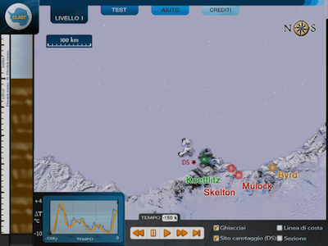

Scenario of Ross Sea area (in CLAST)
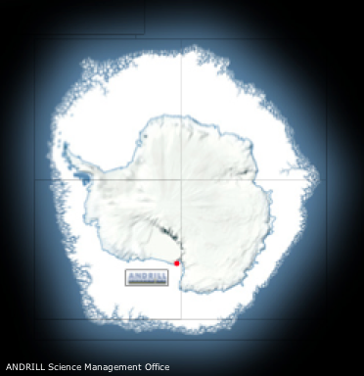 | 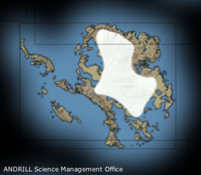
Figure A | Figure B

During a warming phase glacial flows transport their clasts
- More and more away from the coastline
- even closer to the coastline

When does the not anchored shelf retreat completely and then disappear?
- At the recorded maximum temperatures
- When temperatures are very low

THE GLACIERS

Which is the closest glacier to the drilling site?
- Koettlitz
- Skelton
- Mulock
- Byrd

Launch the animation and look at what appears in the research area.

What do the colored paths from the four glaciers represent?
- Glacial flows
- Water rivers

What do the moving colored dots represent?
- The glacial debris rolling on ice
- The glacial debris moving with the ice

What do the different debris colors represent?
- Debris from different rocks (kind of rocks)
- Debris from different glaciers (provenance)

THE SEDIMENTS CORE

The sediments being at the bottom of the column are:
- The oldest ones
- The youngest ones

Look carefully at what happens in the column of sediment during the animation, then answer:

How can you describe the sediments deposited during the cooling phases?
- well laminated (like blades), evident stratification formed by many thin layers
- more homogeneous, stratification not evident, formed by many thick layers sometimes a little bit chaotic

How can you describe the sediments deposited during the hot phases?
- well laminated (like blades), evident stratification formed by many thin layers
- more homogeneous, stratification not evident, formed by many thick layers sometimes a little bit chaotic

Now look in particular at the predominant color of the sediments accumulating in the site.
Run the animation between - 150Ky and - 120 Ky

The temperature during this time
- has been increasing
- has been decreasing

The ice shelf during this time
- has been advancing
- has been retreating

The sequence of the sediments colors accumulating in the column during this time period is
- Yellow / orange / green
- Yellow / green / orange
- Green / yellow / orange

That means that the debris initially come mainly from glaciers that are...
- Farther away from the drilling site
- Closer to the drilling site

What happens at about -137 Ky?
- The drilling site is located on the floating shelf and fine-grain stratification becomes evident
- The drilling site is located on the anchored shelf and fine-grain stratification becomes evident
- The drilling site is located on the floating shelf and sediments appear more homogeneous
- The drilling site is located on the anchored shelf and sediments appear homogeneous
What happens at about -131 Ky?
- The drilling site is located in corrrespondance to the floating shelf
- The drilling site is located in corrrespondance to the anchored shelf
- The drilling site is located offshore

Notice that sometimes icebergs can pass over the drilling site. Pebbles of different size can be dropped out them(dropstones). Consequently, at the drilling site there is deposition of:
- only large clasts
- large clasts and fine sediments
- fine sediments

When the shelf is totally retreated, is it possible that sediments coming from photosynthetic organisms can accumulate at the drilling site?
- Yes, because the sunlight filters and makes photosynthesis possible
- No, because the sunlight never penetrates the water
- Yes, because photosynthesis is independent of the presence of shelf
- No, because photosynthesis doesn’t occur in the sea

Look at the following scenario
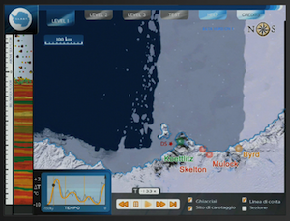
You can say that:
- At the drilling site there is / there is not a floating / anchored shelf
- It represents a warming / cooling stage with retreat / advance of the shelf
- The grounding line is located southward / northward of the site
- The stratification in the column of sediment is evident / not evident

Look at the following scenario
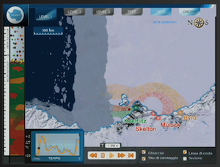
what kind of sediments have been depositing at the drilling site?
- Homogeneous sediments, coming mainly from Koettlitz and Mulock glaciers
- Fine laminated sediments from the Mulock Glacier
- Homogeneous sediments coming just from the glacier Koettlitz
- Sediments of mainly marine origin

Having just this information, can you deduce that the shelf is advancing?
- Yes, because the site is located on the anchored drilling shelf
- No, because I have not enough information
- Yes, because the glacial flows are strong
- No, because it is retreating

In regards to the position of the drilling site, the grounding line is placed:
- Northward
- Southward
- At the site of drilling
- It is impossible to have this information

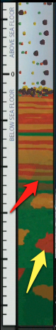 | Look at the figure representing the sediments core and choose the correct alternative in each of the following sentences:  - The yellow arrow indicates a large clast that probably is detached from an iceberg / is settled offshore  - The red arrow indicates the transition between two different modes of sedimentation: from open sea to floating shelf / from floating shelf to open sea  - Regarding the time, the shelf at drilling site moved from a retreat to an advance stage/ from an advance to a retreat stage  - In regard to the temperature variation along all the core portion, we can say that it has been increasing / decreasing  - I can make prediction/ I can't make prediction about what will happen in the core hereafter because I have sufficient / insufficient data.

Read the following summary and correct any mistakes. The wrong terms are only 6 and they are nouns or adjectives, NOT verbs.

When a core is recovered from the seafloor, it is possible to see sediments of different /same origin and size. They can have been deposited in different ways. The sediments deposited at deeper depths are older /more recent. When we find sediments of glacial origin, we may argue that they originated from glaciers and therefore have been deposited during a cold /warm/ period. In particular, we find sediments from glaciers farther from/closer to the drilling site during the coldest stages, whereas the nearby/distant glaciers abandon more sediment during less cold stages. When the shelf is completely retreated and at the site of drilling there is open sea /floating sheet condition, fine sediments are deposited, which are rich in organic matter (in particular photosynthetic microalgae). Among the fine sediments it is possible sometimes to find very large clasts, coming from icebergs /glaciers that pass over the site of drilling.

